Assignment 4

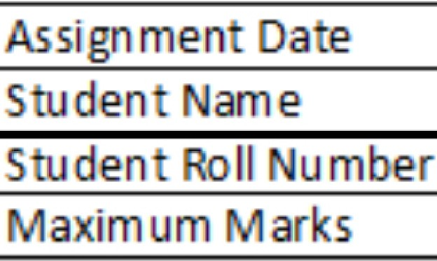WOKWI PROGRAM

# 02-11-2022

# LAXMINARAYANANK.D

732919ECR077

[PDFelement](http://cbs.wondershare.com/go.php?pid=5239&m=db)

Team ID : PNT2022TMID22857

**PROGRAM**

Smart Waste Management System for Metropolitan Cities ASSIGNMENT 4:

Write code a1nd connections in wokwi for ultraso1nic sensors.

Whenever distance is less than 100 ems send "alert11 to ibm cloud and display in device recent events.

Upload document with wokwi share link and ima1ges of ib1m cloud

**CODE•**

#include <WiFi.h>

#include <PubSubClient.h> WiFiClient wifiClient;

String data3;

#define ORG "4yi0vc"

#define DEVICE TYPE 11nodeMcu11 #define DEVICE_ID 11Assi,g1nment4" #define TOKEN 11123456789"

#define speed 0.034

#define led 14

char server[]= ORG ".messaging.internetofthings.ibmcloud.com"; char publishTopic[] = 11iot-2/evt/Data/fmt/json";

char topic[] = "iot-2/cmd/home/fmt/String"; char authMethod [] = 11 U1se-token-auth";

char token[] = lOKEN;

char clientid[] = 11d:11 ORG 11 11 DEVICE_TYPE 11 1 DEVICE_ID;

: :'

PubSubClient client(server1 1883, wifiClient); void publishData();

canst int trigpin=S; canst int echopin= 18; String command; String data="";

long duration; float dist; void setup()

{

SeriaI.begin (115200); pinMode(led, OUTPIUT); pinMode(trigpin, OUTPUT);. pinMode(echopin, INPUT); wifiConnect(); mqttConnect();

}

void loop() {

bool isNearby = dist< 1010; digitalWrite(led, isNearby);

publishData(); delay(S010);

if (!client.loop()) { mqttCon1nect();

}

}

void wifiC011nect() {

Serial.print(11Connecting to"); serial.print("Wifi"); WiFi. begin("Wokwi-GUEST", "", 6);

while (WiFi.status() != WL_CONN ECTED) { delay(S00);

Se. r1aI.p.r1nt( II.II) ;

}

SeriaI.,print( "WiFi connected, IP address: 11 Serial.println(WiFi. localIP());

);

}

void mqttConnect() {

if (!client.connected()) {

Serial.print("Reconnecting MQTT client to"); Serial.println(server); while (!client.c:onnect(clientld, authMethod, token)) {

Serial. print("."); delay(500);

}

initManagedDevice(); SeriaI. println();

}

}

void initManagedDevice() {

if (client.subscribe(topic)) {

// Serial.println(client.subscribe(topic)); Serial.println("IBM subscribe to cmd OK");

} else {

Serial.println1("subscribe to cmd FAILED");

}

}

void publishDa1ta()

{

digitaIWrite(trigpin,lOW); digitaIWrite(trigpin,IHIGIH); delayMicroseconds(10); digitaIWrite(trigpin,lOW); duration =pulseln(echopin,H[GH); dist=duratio,n*speed/2;

if(dist< 100){

String payload = "{\"Normail Distance\":"'; payload += dist;

payload + = 11

}";

SeriaI. print("\n"); Serial.print(11Sending payload:"); SeriaI. println(payload);

if (client. publish(publishTopic, (char*) payloadl.c_str())) { Serial. println("IPrublish OK");

}

}

if(dist>101 && dist<111){

String payload = "{\11Alert dlistance\1 payload += dist;

': ";

payload + = 11

}";

SeriaI. print( 11\n11 Serial.print(11Sending payload:"); SeriaI.println( payload);

);

if(client. publish(publishTopic, (char*) payload].c_str())) {

Serial.println("Warning crosses 110cm -- it automaticaly of the loop"); digitalWrite(led,HIGH);

}else {

Serial. println("IPrublish FAILED");

}

}

}

void callback(char* subscribeTopic, byte* payload, unsigned] int payloadLength){ Serial. print(11callback invo,ked for topic:");

Serial.println( subscribeTopic); for(int i=0; i<payloadlLength; i++){

dist+= (char)payload[i];

}

Serial.println("data:"+ data13); if( data3= ="lighton" ){

SeriaI.println(data3);

digitalWrite(led,HIGH);

}

data 3="" ·I

}



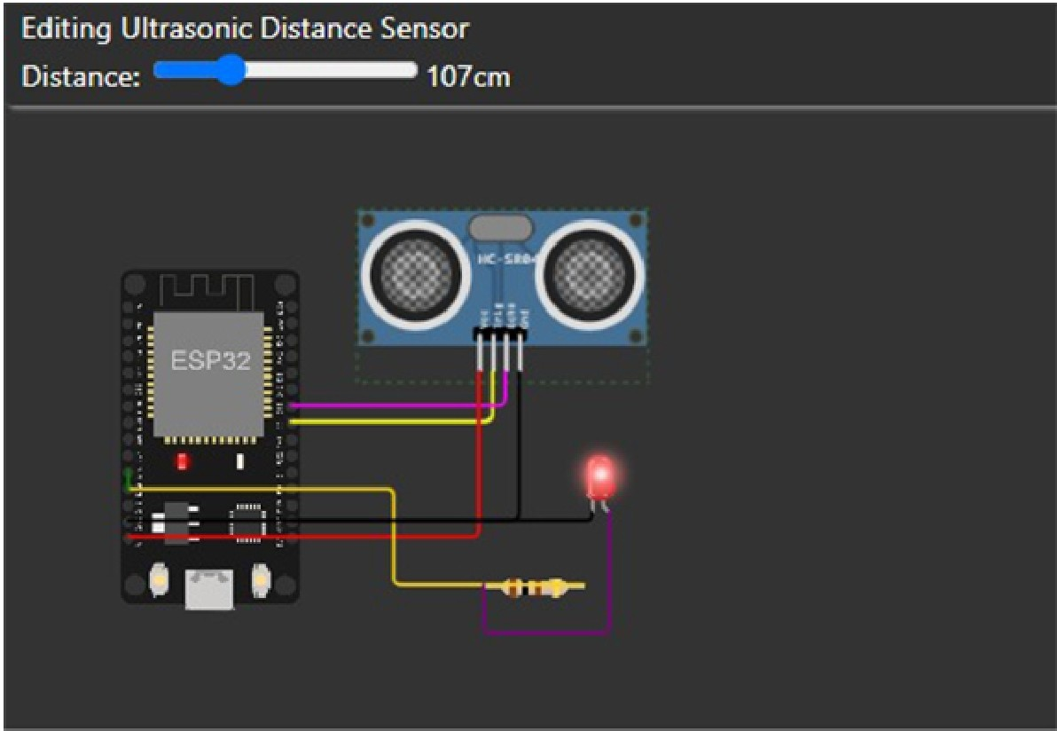

Sending payload: {"Alert distance":106.98}

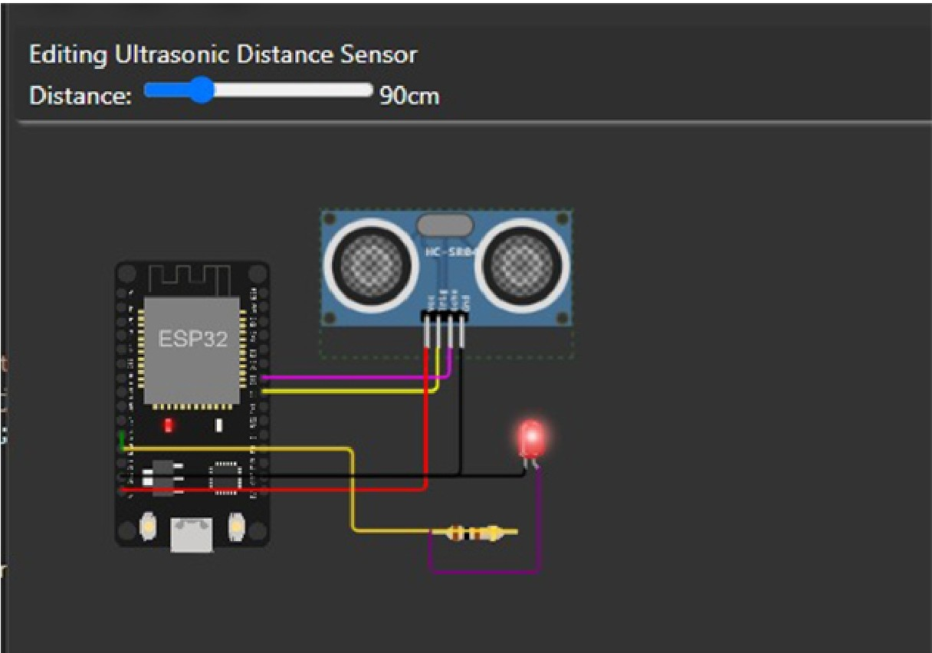

Sending payload: {"Normal Distance":89.95}

Pu1blish OK

Sending payload:{"'Normal Distance":89.95}

Pu1blisl-OTKI

Sending payload: {"Normal Distance":89.95}

PUJblisl-TI OK

Sending payload:{"Normal Distance":89.98}

Pu1blish OK

Sending payload:{"Normal Distance":89.95}

PUJblisl-TI OK

Sending payload:{"Normal Distance":89.95}

PUJblish OK

Warning crosses 110cm -- it automaticaly of the loop

Sending payload: {"Alert distance" :106.98}

Warning crosses 110cm -- it automaticaly of the loop

Sending payload: {"Alert distance":105.98}

Warning cro5ses 110cm -- it automaticaly of the loop

Sending payload: {"Alert distance" :105.98}

Warning crosses 110cm -- it automaticaly of the loop

Sending payload: {"Alert distance":106.98}

Warning crosses 110cm -- it automaticaly of the loop

**1) when distance under 1001cm it wil show norm1ol distionce**

Sending payload: {"Alert distance":106.98}

Warning crosses 110cm -- it automaticaly of the loop

**2) when distance cross 100 cm**

**it wil show ALERT with warning mes,sage distance**

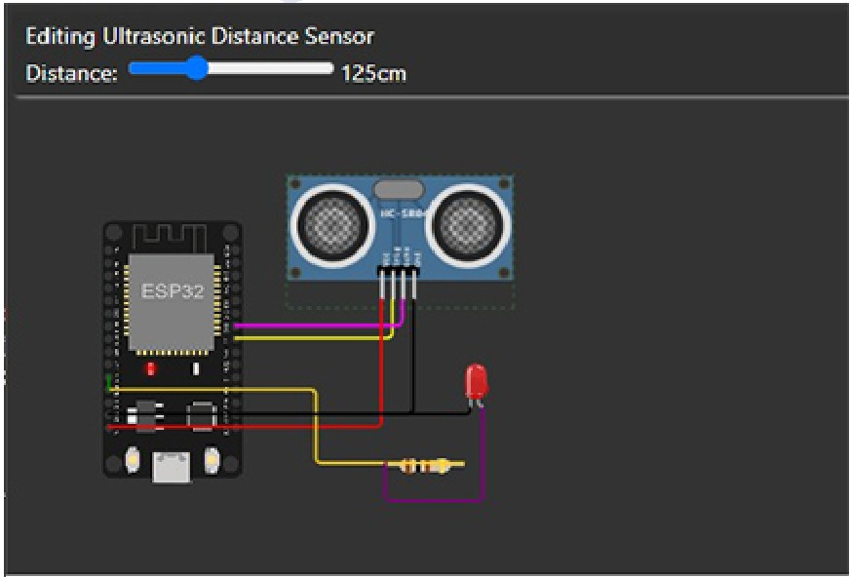

Sending payload:{"Alert distance":106.96}

\-Jarning ,i;;rosses l 10 m -. it • to111aticaly of the l<,op

S@ndiog payloa,d:{"Al@rt distanc@":106.98}

War"'nir11g cros.s.es 110,i:m - - it automaticaly cf t e loop

Sending payloa·d:{"Alert distance'":106.98}

hlairni11g crosses 110 m -. it utomaitic ly of the l,oop

[S@ndir.g](mailto:S@ndir.g) payloa,d: {"Al•rt distanc@":106.98}

\-'Jarning ,cr,os.s.es 110<m - - it automaticaly of the loop

Sending p•yloa-d:{"Alert distance":106.98}

\.J.arni11g crosses 110 m -. it auto■aticaly of the loop

Sendir1g payloa,d: {"Alert distanc@":106.98}

\-Jarn ir.g crosses 110<m -. it automaticaly of the loop

when it cross above 110 cm it totaly

move to iff state once it reduce to 110 it on again

**IBM CLOUD DUPUY**

Recentt i;;vents

Recent Events The reeeru events li3l-.ci show the liq,:s-1r,e.am of datei 1hat is coming e.nd 10mg from tti1s device.

Thie reci.!nt eve111ts. li:!lited show the liv-e :stream of da.ta thai i:!I coming and ,B.Oing from this device_

E'a'i!nt Vi!il!H! Farm,at La:5,·I Ri!'C I,.,

**E...,I** V•lue

Oa:a, {'Alort d, tanoe":106. SI

Formml LulReocm:d

Drn111 i•No,rme.l Dis:1anc:E"::69.95}

j Ol'l a iew s;e,cQOd,5, s.J!:o

o.,. **{"Alon** dilitanot":107.03\

JSOn 

Dai.a r-N'ormal Dislanoe";;fl'9.. 5} j!:ion a lew 1:.eoom:ls ai1:o

Data -No-rmal Ois1.an«i''::fl'9.95} j:son a *lew* Se.t(ld& a.go, Oa:" {'Alon d<Stane<t":106.981

011111 l"Nonnal Di•oon0<>":a9.95) j:son a icw ,:iKOOi:b qo 0.&?ll {'Alon d- 1;.n •:106.911}

Da;:-a *i* Normal Dis1anOE!":;B'9_'95} json a iew seconds a130 Datil {"Alt;I!cfitooQi":lOij'.1 1

json



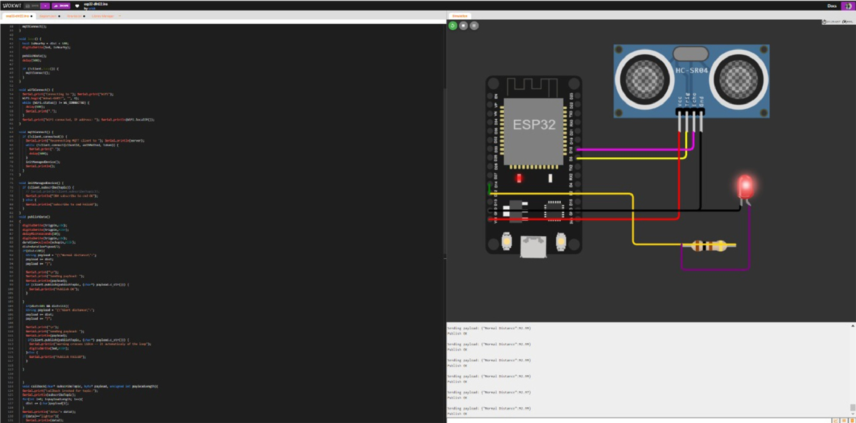

# Co1111ect io11Infor1naition

Basic co nee ion in ormation about this device.

Device ID Device Type Date Added Added By

Connection Status

Assignmen 4

nodeMcu

23 Oct 20.22 07:20

'920219110 [302@smartinternz.com](mailto:302@smartinternz.com)

Disconnec ed

Last Connected: 01 NOV 202216:5'7

Clien Address: 145 ..40.94.93 Insecure

Duration: 3 minutes

Data Transferred: 1 .4 KB

# Recent Eve11ts

The recent events Listed shows the live stream of data that is coming and going om his device.

E n Value Format Last Received

Da a {" orn1al Distanc:e":92.99. **JSOn** a few seconds ago

.

Da a {" orn1al Distance":92.99. .

**JSOn**

a few seconds ago

Da a {" orn1al Distance":92.99. **JSOn** a few seconds ago

.

Da a {" ormal Distance":92.99. **JSOn** a few seconds ago

.

Da a {" orn1al Distance":92.99

.

**JSOn** a few seconds ago

**WDRI< FLOW Lll(E IN description**